Walkersville Evangelical Presbyterian Church
October 12, 2025 10:00 a.m.

Prelude

Greeting & Announcement

Bringing in the Light

*Call to Worship “Jesus, Name Above All Names” #86

*Prayer

*Hymn “They’ll Know We Are Christians” #429

*Prayer of Confession (Psalm 103:8,11,12)
The Lord is merciful and gracious, slow to anger and abounding in steadfast love…For as the heavens are high above the earth, so great is his steadfast love toward those who fear him; as far as the east is from the west, so far does he remove our transgressions from us.

*Silent Confession of Sin

*Assurance of Pardon
I was buried with Christ. I have been raised with Christ. In Christ I am a new creation. In the name of Christ I am forgiven.

*Gloria Patri We will Glorify
We will glorify the Father, We will glorify the Son,
We will glorify the Spirit, God Almighty three in one.
As He was in the beginning, so He is eternally,
God unchanging, never wavering, holy, loving Trinity.

Children’s Moment

Offertory “As the Deer with I Love You, Lord”
By: Martin J. Nystrom, arranged by Camp Kirkland

*Doxology & Prayer #814
Praise God from whom all blessings flow.
Praise him, all creatures here below.
Praise him above, ye heavenly host.
Praise father, Son and Holy Ghost. Amen.

Sermon: “Do what you’re told!”
Scripture: 1 John 2: 1-6

*Hymn “Living for Jesus” #605

Prayer

*Hymn “I Then Shall Live” #444

*Benediction

*Those who are able, please stand.

This Week
- Sunday, October 12
-Sunday School– 9:00 am
-Worship - 10:00 am, 1 John 2:1-6
-Worship Committee – 11:15am, FH
- Oct. 13-17
-Chicken N Dumpling Prep Week
- Monday, October 13
-Men’s & Women’s Monthly Bible Study – 7pm, Fellowship Hall
- Wednesday, October 15
-Bible Study - 3pm, Fellowship Hall
-Prayer Time - 4pm, Fellowship Hall
-MaryVille Youth – 6:30pm, WEPC
- Thursday, October 16
-Session – 7pm, Library
- Saturday, October 18
-Chicken N Dumplings
- Sunday, October 19
-Sunday School– 9:00 am
-Worship - 10:00 am


Upcoming Events

Chrismon Decorating, Mon., October 20, 7pm



JAARS Day, Oct. 25, 9am-4pm, 7405 Jaars Rd., Waxhaw
Senior Covered Dish Lunch,
Oct. 28, 11:30 am
UC-EPC Women
Fall – Friendsgiving Luncheon, Sat, Nov. 15, 10am-1pm
WEPC, bring your favorite finger food to share and enjoy a time of fellowship, and worship through music and testimonies!

Praises to the LORD
- Operation Christmas Child Mission of the Month: Pray that we as a church can provide at least 50 boxes!

Prayers for Grief

Prayer Request
- Boyet Twitty (10/1) – recovering from back procedure
- Kenny Schott. (10/8) – Continued heart problems. Additional surgery needed.
- Larry Medlin, Sr. (10/1) – 2nd lung biopsy
- Fran Griffin (10/1) – Venous ablation 10/16
- Clay Murray (10/1) – Cataract surgery 10/16
- Audrey Schott (10/1) – Shoulder surgery 10/16
- Rick Simpson (10/1) - Foot problem
- Neil Gordon (10/1) – Under Hospice. Kim Dion’s dad.
- Bud Willadsen (9/24) – recovery from ministrokes.
- Erica Robinson (9/24) – recovery from broken ankle.
- David Couick (9/24) – cancer returned.
- Saylor Grace Hardy (9/24) – severe headaches. 2 yr.-old daughter of Dillon & Kayla Hardy; Granddaughter of Tim & Ivey Hardy.
- Bryan Carrubba (9/17) – Stage 4 cancer, infection, pneumonia. Brother of Frances Gamble.
- Greg Atkins (9/17) – Stroke. Dean Haney’s cow-worker’s brother.
- Rik Parcell (9/17) – Car accident: multiple broken bones, upcoming surgeries. Debbie Rankin’s cousin

Active Military
- Devin Moser | - Luke Mault
- Chad Clonch | - Chris Rankin
- Peyton Maguffey | - Garret Melton
- Jarrett Setliff | - Matthew Luke

Weekly Prayers
Mon: | Dennis & Debbie Robinson
Tue: | Erica Robinson
Wed: | Neil & Kristin Robinson - Savannah
Thur: | Grady & Ann Rose
Fri: | Tom & Barb Salisbury
Sat: | Larry & Audrey Schott
Sun: | Rick & Sherri Simpson
WELCOME GUESTS! We’re so glad you’re here! Whether this is your first visit or you’re returning, you are a blessing to our church family. Please take a moment to fill out a visitor card and place it in the offering plate so we can connect with you. We hope you feel God’s love and peace with us today, and we invite you back anytime.

Hearing Assistance Devices Please see the technician in the sound room if you need a hearing device.

The Church Nursery is available for children from birth to 5 years old. Please see the greeter for assistance or take the children to the nursery in the Education Wing.

Nursery Schedule
- 10/12: Gretchen Presson & Wilson Johnston
- 10/19: Chris & Jennifer Trull
- 10/26: Tiffany Presson & Lily Wilson
- 11/2: Sherri Simpson & Brooklyn Hardy

Church office hours: M-W-F 9:00 am - 3:00 pm
Pastor Paul Rankin (814) -279-5055 walkersvilleepcpastor@gmail.com
Office Hours: Mon-Thurs: 8:30 - 5:00 or by appt.
Music Director, Sue Thornton Organist, Layne Dewlen
Walkersville Evangelical
Presbyterian Church
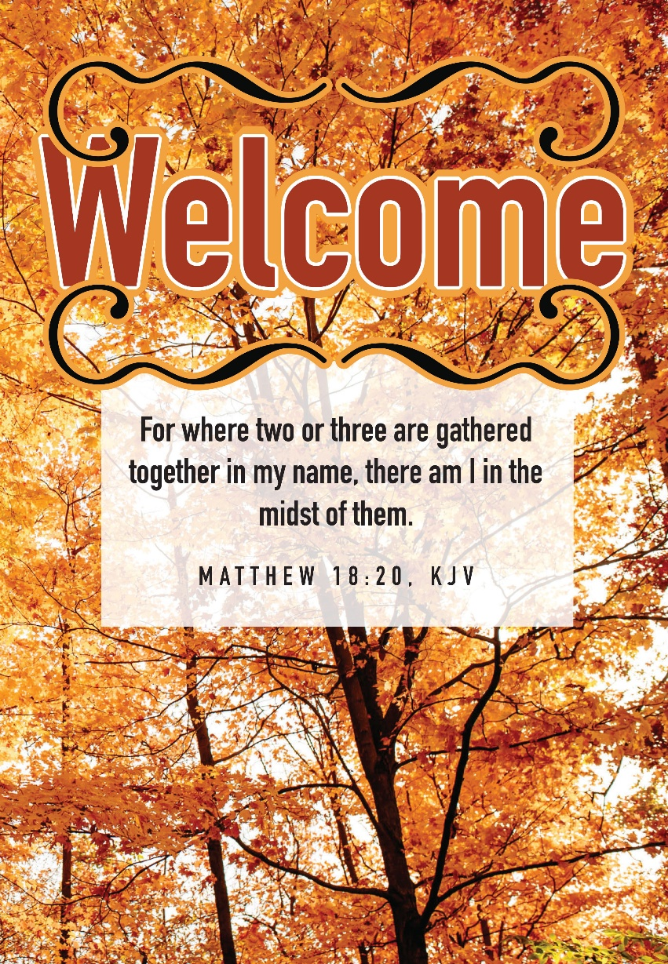

October 12, 2025
6204 Brady Rd, Waxhaw, NC 28173 704-843-3612
Walkersvilleepc@gmail.com www.walkersvilleepc.org

