Walkersville Evangelical Presbyterian Church

February 18, 2024 10:00 a.m.

Pastor Paul Rankin

Pianist, Sue Thornton Organist, Layne Dewlen

Prelude

Greeting & Announcement

*Call to Worship “Glorify Thy Name” #9

*Prayer

*Hymn“ “To God Be the Glory” #56

*Confession (Romans 5:8)
But God demonstrates his love for us in that while we were still sinners Christ died for us.

*Silent Confession of Sin

*Assurance of Pardon (Psalm 51:10, 12)
Create in me a clean heart, O God, and put a new and right spirit within me…Restore to me the joy of your salvation and sustain in me a willing spirit.

*Gloria Patri We will Glorify
We will glorify the Father, We will glorify the Son,
We will glorify the Spirit, God Almighty three in one.
As He was in the beginning, so He is eternally,
God unchanging, never wavering, holy, loving Trinity.

Children’s Moment

Offertory Organ Special Layne Dewlen

*Doxology & Prayer

Scripture: Ephesians 1:4-6 pg. 192 NT Pew Bible
Guest Speaker: Matthew Kirk

*Hymn “Worthy of Praise” #153

Prayer

*Hymn “Praise, My Soul, the King of Heaven” #1

*Benediction

*Those who are able, please stand.

Today’s Sermon: Ephesians 1:4-6
Scripture/Verses: ______________________________________
______________________________________________________Key Points: ___________________________________________ __________________________________________________________________________________________________________________________________________________________________

Notes: ________________________________________________
____________________________________________________________________________________________________________
______________________________________________________________________________________________________________________________________________________________________________________________________________________________________________________________________________________________________________________________________________________________________________________________________________________________________________________________________________________________________

Walkersville Evanglical Presbyterian Church
Teaching Elder: Pastor Paul Rankin (814-279-5055)
Ruling Elders:
Class of 2024 | Class of 2025 | Class of 2026
Larry Schott,  (704-774-1691) | Dennis Robinson ,  (704-291-056) | Rick Gay ,  (704-843-5733)
Bob Stirton,  (704-361-4888) |  | Ann Rose,  (854-999-8061)

6204 Brady Rd, Waxhaw, NC 28173 704-843-3612
Walkersvilleepc@gmail.com www.walkersvilleepc.org
Facebook: Walkersville Evangelical Presbyterian Church
Pastor Paul’s Office Hours: Mon.-Thur., 8:30 – 5:00 or by appt.
Caitlin’s Hours: M,W, F 8-2
Walkersville Evangelical
Presbyterian Church

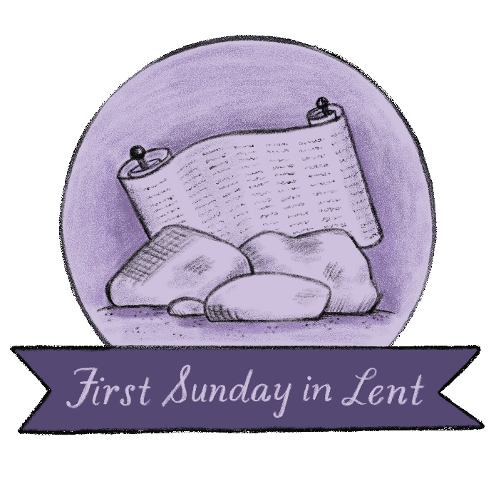

February 18, 2024 Organized 1908

