Walkersville Evangelical Presbyterian Church

March 17, 2024 10:00 a.m.
Pastor Paul Rankin Pianist, Sue Thornton Organist, Layne Dewlen

Prelude

Greeting & Announcement

*Call to Worship “More Precious than Silver” #88

*Prayer

*Hymn“ “At Calvary” #492

*Confession
Almighty God,
We judge others with a standard we never use for ourselves. We see the speck in others’ eyes while ignoring the log in our own. Forgive us, O God, and cleanse us from hidden faults, that the words of our mouths and the meditations of all our hearts may be acceptable to you, our Rock and our Redeemer.

*Silent Confession of Sin

*Assurance of Pardon (1 Peter 3:18)
For Christ also died for sins once for all, the righteous for the unrighteous, in order that he might bring us to God, being put to death in the flesh but made alive in the spirit.

*Gloria Patri We will Glorify
We will glorify the Father, We will glorify the Son,
We will glorify the Spirit, God Almighty three in one.
As He was in the beginning, so He is eternally,
God unchanging, never wavering, holy, loving Trinity.

Children’s Moment

Offertory “My Savior’s Love”, “Once Again” Choir
By: Charles H. Gabriel, arranged by Marty Parks
By: Matt Redman, arranged by Marty Parks

*Doxology & Prayer

Scripture: Matthew 6: 19-21 pg. 6 NT Pew Bible
“How much have you saved?” Pastor Paul Rankin

*Hymn “I’d Rather Have Jesus” #506

Prayer

*Hymn “Jesus is Lord of All” #599

*Benediction

*Those who are able, please stand.
Today’s Sermon: Matthew 6:19-21

Notes: ________________________________________________
____________________________________________________________________________________________________________
____________________________________________________________________________________________________________________________________________________________________________________________________________________________________________________________________________________________________________________________________________________________________________________________________________________________________________________________________________________________________________________________________________________________

Walkersville Evanglical Presbyterian Church
Teaching Elder: Pastor Paul Rankin (814-279-5055)
Ruling Elders:
Class of 2024 | Class of 2025 | Class of 2026
Larry Schott,  (704-774-1691) | Dennis Robinson,  (704-291-056) | Rick Gay,  (704-843-5733)
Bob Stirton,  (704-361-4888) |  | Ann Rose,  (854-999-8061)

6204 Brady Rd, Waxhaw, NC 28173 704-843-3612
Walkersvilleepc@gmail.com www.walkersvilleepc.org
Facebook: Walkersville Evangelical Presbyterian Church
Pastor Paul’s Office Hours: Mon.-Thur., 8:30 – 5:00 or by appt.
Caitlin’s Hours: M,W, F 8-2

Hearing Assistance Devices Please see the technician in the sound room if you need a hearing device.

The Church Nursery is available for children, from birth to 5 years old. Please see the greeter for assistance or take them to the nursery in the Education Wing. Nursery Volunteer: Caitlin Hardy & Kennedy Yeakley
Walkersville Evangelical
Presbyterian Church

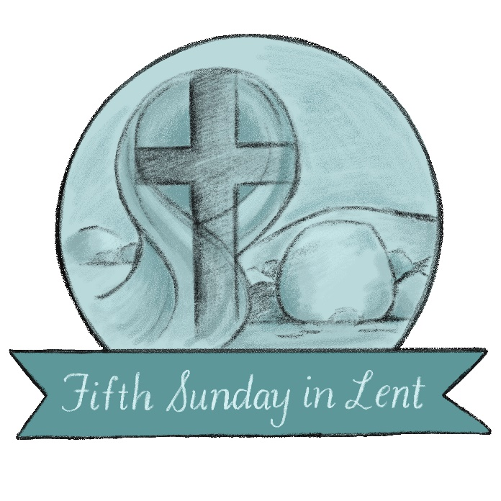

March 17, 2024 Organized 1908

