Walkersville Evangelical Presbyterian Church

May 5, 2024, 10:00 a.m.
Pastor Paul Rankin Pianist, Sue Thornton Organist, Layne Dewlen

Holy Communion

Prelude

Greeting & Announcement

*Call to Worship “We Bring the Sacrifice of Praise” #36

*Prayer

*Hymn “The Solid Rock” #526

*Confession
Almighty God,
In the grace and mercy we find at your Table, we pray for healing and nourishment. Help us to examine our hearts, be obedient to your commands, and again strength to follow the example of our Lord and Savior Jesus Christ.

*Silent Confession of Sin

*Assurance of Pardon
Our God has cleansed and forgiven us. He has filled us with his Spirit, enabling us to declare his praise.

*Gloria Patri We will Glorify
We will glorify the Father, We will glorify the Son,
We will glorify the Spirit, God Almighty three in one.
As He was in the beginning, so He is eternally,
God unchanging, never wavering, holy, loving Trinity.

Children’s Moment

Offertory “Calvary Covers It All” Choir
By: Mrs. Walter G. Taylor, arranged by Dennis Allen

*Doxology & Prayer

Scripture: Romans 2:25-29 pg. 153 NT Pew Bible
“Are you a Jew?” Pastor Paul Rankin

Prayer

*Special Music “For All My Sins”
Layne Dewlen & Moira Efird

Invitation to the Lords Table

Affirmation of Faith See Insert

*Hymn “Redeemed” #516

*Benediction

If you would like an elder to pray with you, please come to the front.
*Those who are able, please stand.
Today’s Sermon: Romans 2:25-29

Notes: ________________________________________________
____________________________________________________________________________________________________________
________________________________________________________________________________________________________________________________________________________________________________________________________________________________________________________________________________________________________________________________________________________________________________________________________________________________________________

Walkersville Evanglical Presbyterian Church
Teaching Elder: Pastor Paul Rankin (814-279-5055)
Ruling Elders:
Class of 2024 | Class of 2025 | Class of 2026
Larry Schott,  (704-774-1691) | Dennis Robinson,  (704-291-0856) | Rick Gay,  (704-843-5733)
Bob Stirton,  (704-361-4888) |  | Ann Rose,  (854-999-8061)

6204 Brady Rd, Waxhaw, NC 28173 704-843-3612
Walkersvilleepc@gmail.com www.walkersvilleepc.org
Facebook: Walkersville Evangelical Presbyterian Church
Pastor Paul’s Office Hours: Mon.-Thur., 8:30 – 5:00 or by appt.
Caitlin’s Hours: M,W, F 8-2

Hearing Assistance Devices Please see the technician in the sound room if you need a hearing device.

The Church Nursery is available for children, from birth to 5 years old. Please see the greeter for assistance or take them to the nursery in the Education Wing. Nursery Volunteer:
5/5/2024: Rhonda McManus & Bryleigh or Jase
5/12/2024: Caitlin Richardson & Caleb Hardy
5/19/2024: Gretchen Presson & Robert Laton
Walkersville Evangelical
Presbyterian Church

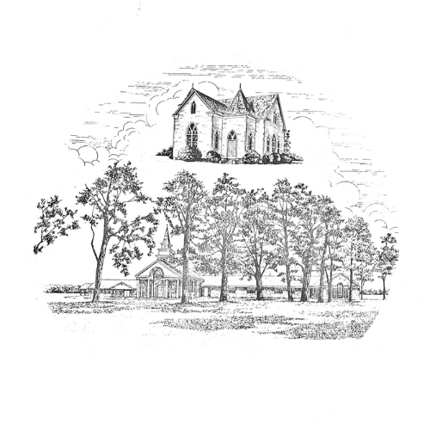

May 5, 2024 Organized 1908

