Walkersville Evangelical Presbyterian Church

April 28, 2024, 10:00 a.m.
Pastor Paul Rankin Pianist, Sue Thornton Organist, Layne Dewlen

Prelude

Greeting & Announcement

*Call to Worship “He Is Exalted” #36

*Prayer

*Hymn “Jesus Calls Us” #592

*Confession (Isaiah 1:18)
Come now, let us reason together, says the Lord:
Though your sins are like scarlet, they shall be as white as snow; Though they are red like crimson, they shall become like wool.

*Silent Confession of Sin

*Assurance of Pardon (Ephesians 2:1; 4-5)
You were dead through your trespasses and sins…But God, who is rich in mercy…made us alive together with Christ-by grace you have been saved.

*Gloria Patri We will Glorify
We will glorify the Father, We will glorify the Son,
We will glorify the Spirit, God Almighty three in one.
As He was in the beginning, so He is eternally,
God unchanging, never wavering, holy, loving Trinity.

Children’s Moment

Offertory “Untitled Hymn (Come to Jesus)” Choir
By: Chris Rice, Arranged by Robert Sterling

*Doxology & Prayer

Scripture: Romans 2:17-24 pg. 153 NT Pew Bible
“What sermon is your life preaching?” Pastor Paul Rankin

*Hymn “I Gave My Life for Thee” #675

Prayer

*Hymn “Revive Us Again” #434

*Benediction

If you would like an elder to pray with you, please come to the front.

*Those who are able, please stand.

Today’s Sermon: Romans 2:17-24

Notes: ________________________________________________
____________________________________________________________________________________________________________
________________________________________________________________________________________________________________________________________________________________________________________________________________________________________________________________________________________________________________________________________________________________________________________________________________________________________________

Walkersville Evanglical Presbyterian Church
Teaching Elder: Pastor Paul Rankin (814-279-5055)
Ruling Elders:
Class of 2024 | Class of 2025 | Class of 2026
Larry Schott,  (704-774-1691) | Dennis Robinson,  (704-291-0856) | Rick Gay,  (704-843-5733)
Bob Stirton,  (704-361-4888) |  | Ann Rose,  (854-999-8061)

6204 Brady Rd, Waxhaw, NC 28173 704-843-3612
Walkersvilleepc@gmail.com www.walkersvilleepc.org
Facebook: Walkersville Evangelical Presbyterian Church
Pastor Paul’s Office Hours: Mon.-Thur., 8:30 – 5:00 or by appt.
Caitlin’s Hours: M,W, F 8-2

Hearing Assistance Devices Please see the technician in the sound room if you need a hearing device.

The Church Nursery is available for children, from birth to 5 years old. Please see the greeter for assistance or take them to the nursery in the Education Wing. Nursery Volunteer:
4/28/2024: Jennifer Trull & Kelsey Johnston
5/5/2024: Rhonda McManus & Bryleigh or Jase
5/12/2024: Caitlin Richardson & Caleb Hardy
Walkersville Evangelical
Presbyterian Church

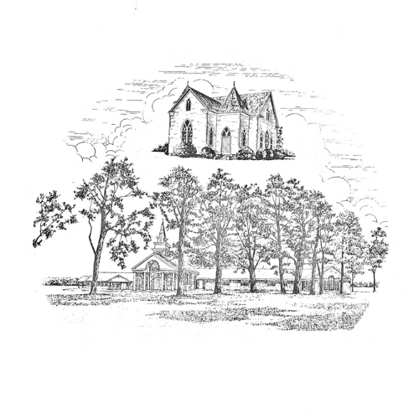

April 28, 2024 Organized 1908

