Walkersville Evangelical Presbyterian Church
November 16, 2025 10:00 a.m.

Prelude

Greeting & Announcement

*Call to Worship “Give Thanks” #170

*Prayer

*Hymn “Freely, Freely” #436

*Prayer of Confession
Merciful God, in your gracious presence we confess our sin. Although Christ is among us as our peace, we are a people divided against ourselves as we cling to the values of a broken world. Lord, have mercy upon us; heal and forgive us. Set us free to serve you in the world as agents of your reconciling love in Jesus Christ.

*Silent Confession of Sin

*Assurance of Pardon (from Psalm 103)
Bless the Lord, O my soul; and all that is within me, bless his holy name! Bless the Lord, O my soul and forget not all his benefits, who forgives all your iniquity…who satisfies you with good as long as you live…For as the heavens are high above the earth, so great is his steadfast love toward those who fear him; as far as the east is from the west, so far does he remove our transgressions from us.

*Gloria Patri We will Glorify
We will glorify the Father, We will glorify the Son,
We will glorify the Spirit, God Almighty three in one.
As He was in the beginning, so He is eternally,
God unchanging, never wavering, holy, loving Trinity.

Children’s Moment

Offertory “Tis so Sweet to Trust in Jesus” Choir

*Doxology & Prayer #814
Praise God from whom all blessings flow.
Praise him, all creatures here below.
Praise Him above, ye heavenly host.
Praise Father, Son and Holy Ghost. Amen.

Sermon: Thomas Davis
“The Jesus Model for Missions (and Local Gospel Outreach)”
Scripture: John 1:14-18; John 20: 19-23

*Hymn “Here I am, Lord” #589

Prayer

*Hymn “So Send I You-by Grace Made Strong” #440

*Benediction

*Those who are able, please stand.

This Week
- Sunday, November 16
-Sunday School– 9:00 am
-Worship - 10:00 am
-Christian Ed Meeting – 11:15 am
-Community Thanksgiving Service – 5 pm, MEBC
- Monday, November 17
-Mission & Outreach– 7:00 pm, Library
- Wednesday, November 19
-Bible Study– 3:00 pm, Fellowship Hall
-Prayer Time – 4:00 pm, Fellowship Hall
-Little Angels & Youth– 5:30 pm, Fellowship Hall
- Thursday, November 20
-Session – 7 pm, Library
- Sunday, November 23
-Sunday School– 9:00 am
-Worship - 10:00 am

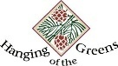
Upcoming Events
“Hanging of the Greens”
You are invited to help decorate the church as we prepare to welcome the LORD Jesus Christ during this Christmas season.
Monday, November 24, at 6 p.m.
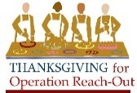
Operation Reach-Out Thanksgiving Day Meal
Thursday, November 27th
12:00 – 2:00 Volunteers needed for clean-up, Monroe, NC
Light the Light - Hosted by Operation Reach-Out
Saturday, December 13, 5:00 pm – 8:00 pm
Lakeland Memorial Park, Monroe
Little Angels & Outsiders Youth
Let’s Celebrate Christmas
Wednesday, December 19, 5:30 till 7:00 p.m.

Praises to the LORD
- Operation Reach-Out Mission of the Month:
- Presley Mae Hardy (10/28) – Born 10/28 to Dillon & Kayla Hardy.
Prayers of Grief
- Elmer Weakland (11/6) –Uncle of Caitlin R.
Prayer Request
- Robin Sells (11/13) – Stage 3 colon cancer
- Caitlin Richardson (11/5) – ultrasound on 11/19
- Fran Griffin (11/5) – 2 more venous ablations
- Karen Trull (11/5) – Health concerns. Hospital
- Martha Allen (10/31) – Various health concerns. Hospital.
- Chuck Gunter (10/31) – Various health concerns. Neighbor of Larry & Audrey Schott.
- Ann King (10/31) – Fighting cancer & fell with 2 fractured vertebrae.
- Larry Medlin, Sr. (10/31) – Stage 3 lung cancer, starts radiation and chemo in 2-3 weeks. Father of Pete & Tiffany Medlin
- Keri Wickerson (10/24) – Enlarged lymph nodes. Scan on 10/28. Wife of Dean’s co-worker.
- Greg Atkins (10/24) – Making progress at rehab.
- Alan Mears (10/19) –Cancer took a turn for the worse
- Mike Edwards (10/16) – Stage 2 lung cancer. Lynn Dewlen’s brother.

Active Military
- Devin Moser | - Luke Mault
- Chad Clonch | - Chris Rankin
- Peyton Maguffey | - Garret Melton
- Jarrett Setliff | - Matthew Luke
- Jesse Parr

Weekly Prayers
Mon: | Daniel & Daisy Craig
Tue: | Layne & Lynn Dewlen
Wed: | Kim Dion
Thur: | Brian Dixon
Fri: | Paul & Peggy Dvorak
Sat: | Rick & Tina Eason
Sun: | Moira & Landon Efird - Aurora
WELCOME GUESTS! We’re so glad you’re here! Whether this is your first visit or you’re returning, you are a blessing to our church family. Please take a moment to fill out a visitor card and place it in the offering plate so we can connect with you. We hope you feel God’s love and peace with us today, and we invite you back anytime.

Hearing Assistance Devices Please see the technician in the sound room if you need a hearing device.

The Church Nursery is available for children from birth to 5 years old. Please see the greeter for assistance or take the children to the nursery in the Education Wing.

Nursery Schedule
- 11/16: Amanda Fesperman & Levi Fesperman
- 11/23: Tammy Mosley & Lily Wilson
- 11/30: Phyllis Norwood & Wilson Johnston
- 12/7: Rhonda McManus & Brooklyn Hardy

Church office hours: M-W-F 9:00 am - 3:00 pm
Pastor Paul Rankin (814) -279-5055 walkersvilleepcpastor@gmail.com
Office Hours: Mon-Thurs: 8:30 - 5:00 or by appt.
Music Director, Sue Thornton Organist, Layne Dewlen

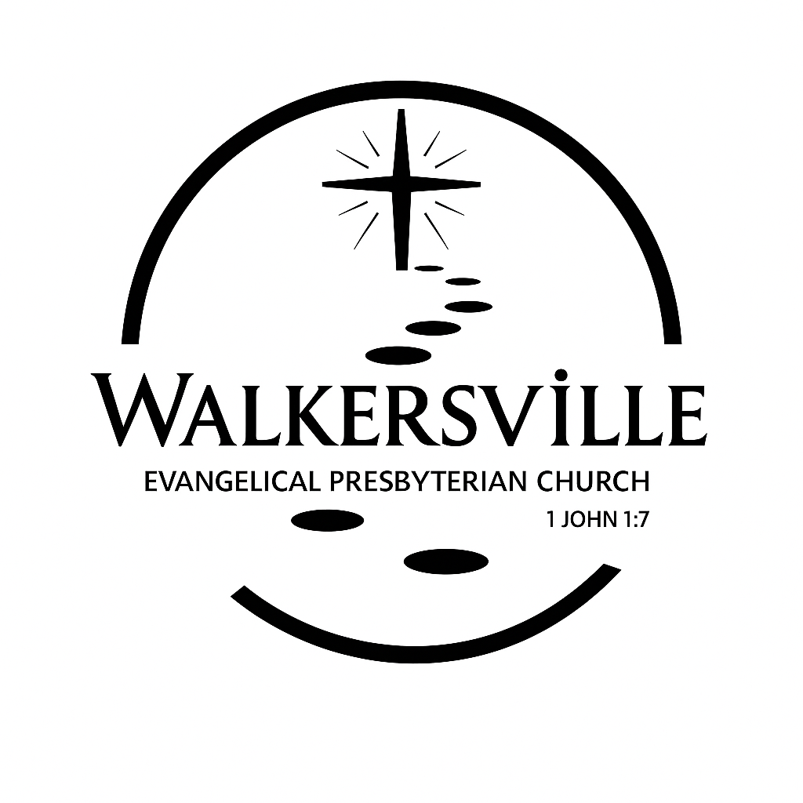

November 16, 2025
6204 Brady Rd, Waxhaw, NC 28173 704-843-3612
Walkersvilleepc@gmail.com www.walkersvilleepc.org

