Walkersville Evangelical Presbyterian Church
October 5, 2025 10:00 a.m.

Prelude

Greeting & Announcement

*Call to Worship “Jesus, Name Above All Name” #86

*Prayer

*Hymn “Christ is Made the Sure Foundation” #403

*Prayer of Confession
Almighty God,
In the grace and mercy we find at your Table, we pray for healing and nourishment. Help us to examine our hearts, be obedient to your commands, and gain strength to follow the example of our Lord and Savior Jesus Christ.

*Silent Confession of Sin

*Assurance of Pardon
Our God has cleansed and forgiven us, enabling us to approach his Table with praise.

*Gloria Patri We will Glorify
We will glorify the Father, We will glorify the Son,
We will glorify the Spirit, God Almighty three in one.
As He was in the beginning, so He is eternally,
God unchanging, never wavering, holy, loving Trinity.

Children’s Moment

Offertory “The Old Rugged Cross with Had it Not Been”
By George Bennard, arranged Russell Mauldin

*Doxology & Prayer #814
Praise God from whom all blessings flow.
Praise him, all creatures here below.
Praise him above, ye heavenly host.
Praise father, Son and Holy Ghost. Amen.

Sermon: “Eye Witness Account”
Scripture: 1 John 1:1-4

Prayer

*Hymn “Lamb of God” #302

Invitation to the Lord’s Table

*Affirmation of Faith “Apostles’ Creed”
Back cover of hymnal

*Hymn “I Love to Tell the Story” #444

*Benediction

*Those who are able, please stand.

This Week
- Sunday, October 5, Holy Communion
-Sunday School– 9:00 am
-Worship - 10:00 am, 1 John 1:1-4
-Leadership Meeting – 11:15am, Fellowship Hall
-Life Chain – 2:15 pm, Waxhaw

- Monday, October 6
-Evening Bible Study – 7:00 pm, Library

- Wednesday, October 8
-Operation Reach-Out Meal – 12pm, Monroe
-Bible Study - 3pm, Fellowship Hall
-Prayer Time - 4pm, Fellowship Hall
-MaryVille Youth – 6:30pm, WEPC

- Thursday, October 9
-Choir Practice – 7pm, Sanctuary

- Sunday, October 12
-Sunday School– 9:00 am
-Worship - 10:00 am, 1 John 1:1-4
-Worship Committee – 11:15am, FH


Upcoming Events

Chicken N Dumplings, October 18!


Chrismon Decorating,
Monday, October 20, 7pm


JAARS Day, Oct. 25, 9am-4pm, 7405 Jaars Rd., Waxhaw

UC-EPC Women
Fall – Friendsgiving Luncheon, Sat, Nov. 15, 10am-1pm
WEPC, bring your favorite finger food to share and enjoy a time of fellowship, and worship through music and testimonies!
Praises to the LORD
- Operation Christmas Child Mission of the Month: Pray that we as a church can provide at least 50 boxes!

Prayers for Grief

Prayer Request
- Larry & Audrey Schott. (10/2) – Covid
- Larry Medlin, Sr. (10/1) – 2nd lung biopsy
- Fran Griffin (10/1) – Venous ablation 10/16
- Clay Murray (10/1) – Cataract surgery 10/16
- Audrey Schott (10/1) – Shoulder surgery 10/16
- Rick Simpson (10/1) - Foot problem
- Boyet Twitty (10/1) – Back procedure
- Neil Gordon (10/1) – Under Hospice. Kim Dion’s dad.
- Bud Willadsen (9/24) – recovery from ministrokes.
- Erica Robinson (9/24) – recovery from broken ankle.
- David Couick (9/24) – cancer returned.
- Saylor Grace Hardy (9/24) – severe headaches. 2 yr.-old daughter of Dillon & Kayla Hardy; Granddaughter of Tim & Ivey Hardy.
- Bryan Carrubba (9/17) – Stage 4 cancer, infection, pneumonia. Brother of Frances Gamble.
- Greg Atkins (9/17) – Stroke. Dean Haney’s cow-worker’s brother.
- Rik Parcell (9/17) – Car accident: multiple broken bones, upcoming surgeries. Debbie Rankin’s cousin
- Paul & Debbie Rankin (8/24) – Radiation through 11/6

Active Military
- Devin Moser | - Luke Mault
- Chad Clonch | - Chris Rankin
- Peyton Maguffey | - Garret Melton
- Jarrett Setliff | - Matthew Luke

Weekly Prayers
Mon: | Tommy Norwood, III
Tue: | Troy & Leah Norwood
Wed: | Alisa Pierce
Thur: | Andrew & Tiffany Presson - Lily Wilson
Fri: | Nick & Gretchen Presson
Sat: | Paul & Debbie Rankin
Sun: | Quinton & Caitlin Richardson - Paisley
Mission Competition Update:
Totals Collected:
Mission | Amount Collected
House of Pearls | $449
Ground 40 | $413
Operation Reach Out | $331
HELP Pregnancy Center | $295
The Blessing Cart | $230
EPC World Outreach | $135
Faith Works | $111
Turning Point | $75
Operation Christmas Child | $60
The Shack | $51
Missionaries | $50
TOTAL COLLECTED | $2,200

WELCOME GUESTS! We’re so glad you’re here! Whether this is your first visit or you’re returning, you are a blessing to our church family. Please take a moment to fill out a visitor card and place it in the offering plate so we can connect with you. We hope you feel God’s love and peace with us today, and we invite you back anytime.

Hearing Assistance Devices Please see the technician in the sound room if you need a hearing device.

The Church Nursery is available for children from birth to 5 years old. Please see the greeter for assistance or take the children to the nursery in the Education Wing.

Nursery Schedule
- 10/5: Debbie Rankin & Lexi Langle
- 10/12: Tiffany Presson & Lily Wilson
- 10/19: Chris & Jennifer Trull
- 10/26: Gretchen Presson & Wilson Johnston

Church office hours: M-W-F 9:00 am - 3:00 pm
Pastor Paul Rankin (814) -279-5055 walkersvilleepcpastor@gmail.com
Office Hours: Mon-Thurs: 8:30 - 5:00 or by appt.
Music Director, Sue Thornton Organist, Layne Dewlen
Walkersville Evangelical
Presbyterian Church
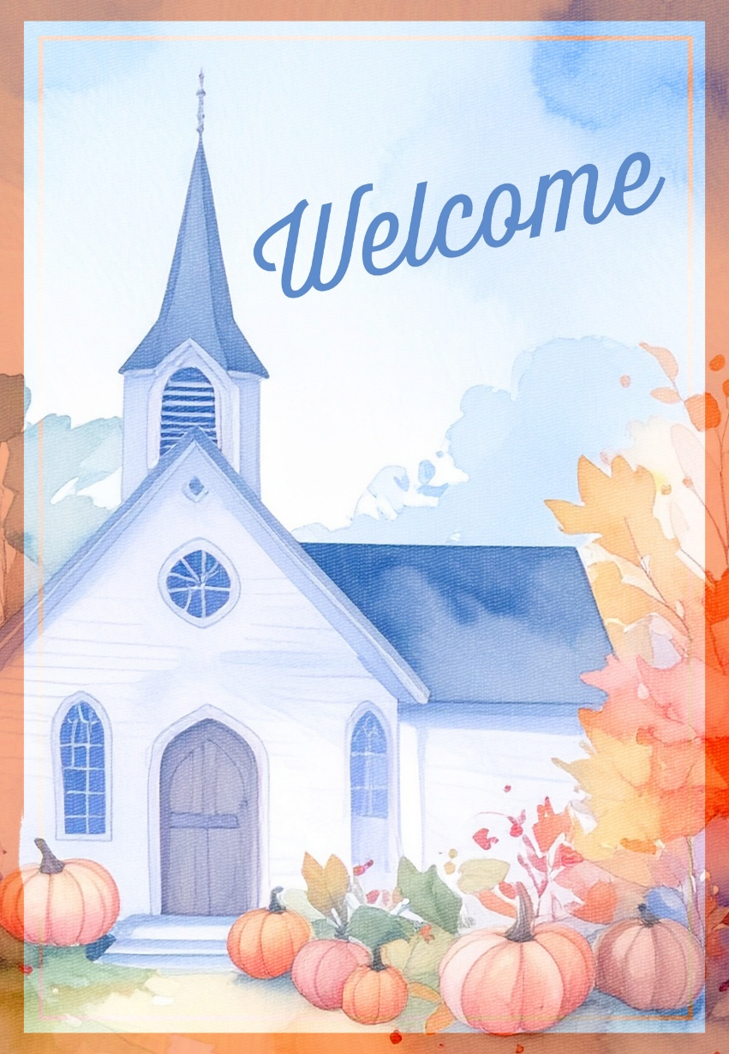

October 5, 2025
6204 Brady Rd, Waxhaw, NC 28173 704-843-3612
Walkersvilleepc@gmail.com www.walkersvilleepc.org

